Statistical Analysis and Predictive Modelling of Medical Insurance Costs to Enhance Healthcare Affordability Outcomes
Soora Namitha Lade. Gunakar Rao
Department of CSE Department of CSE
SR University, Warangal, SR University, Warangal,
Telangana, India. Telangana, India.
ladegunakarrao@gmail.com
sooranamitha@gmail.com

Challa Vyshnavi
Department of CSE
SR University, Warangal
Telangana, India
Vyshnavireddychalla13@gmail.com

Abstract:
The paper presents a comprehensive statistical and machine learning framework to analyze and predict medical insurance costs using a real-world dataset containing individual demographic and health-related attributes. The dataset includes features such as age, gender, body mass index (BMI), number of dependents, smoking status, and region. Data preprocessing techniques such as handling missing values, encoding categorical variables, feature scaling, and exploratory data analysis are applied to ensure data quality and consistency. The dataset is split into training and testing sets using an 80/20 ratio for model validation. Three primary models are implemented: Linear Regression and Ridge Regression for predicting continuous insurance charges, and Decision Tree Regressor to capture non-linear relationships in the data. The regression models use features like age, BMI, and smoking habits as key predictors, achieving strong performance with an R² score of 0.88 and Mean Squared Error (MSE) of 0.42. Ridge Regression (alpha = 1.0) provides similar results, indicating minimal overfitting and stable model performance. The Decision Tree model further improves interpretability by highlighting feature importance, especially the impact of smoking and BMI on insurance costs. Model evaluation metrics and residual analysis are used to assess prediction accuracy and error distribution. Overall, the results demonstrate that statistical and machine learning models can effectively estimate insurance costs, providing valuable insights for insurance providers and individuals to make informed financial and healthcare decisions.
Themes: Medical Insurance Cost Prediction, Statistical Analysis, Machine Learning, Linear Regression, Ridge Regression, Decision Tree, Regression Analysis, Feature Importance, MSE, R² Score, Predictive Modeling, Healthcare Analytics, Cost Estimation.

I.Introduction :
The rising cost of healthcare and medical services has become increasingly complex, posing a significant challenge for individuals, insurance providers, and policymakers in managing and predicting medical expenses. Insurance costs are influenced by multiple factors such as age, body mass index (BMI), lifestyle habits, smoking status, number of dependents, and regional variations, making them difficult to analyze and forecast using traditional statistical techniques alone. Accurate prediction of insurance costs is essential for insurance companies to design fair premium structures and for individuals to make informed financial and healthcare decisions. With the rapid growth of healthcare data, data-driven approaches and machine learning techniques have become effective tools in identifying hidden patterns and relationships within the data.
This study examines the application of fundamental statistical and machine learning models, including Linear Regression, Ridge Regression, and Decision Tree Regressor, to analyze and predict medical insurance costs using a real-world dataset containing demographic and health-related attributes. Data preprocessing methods such as handling missing values, encoding categorical variables, feature scaling, and normalization are applied to ensure data quality and consistency. The research focuses on two primary objectives: (1) predicting continuous insurance charges using Linear and Ridge Regression models, evaluated through Mean Squared Error (MSE) and R² score, and (2) analyzing non-linear relationships and feature importance using the Decision Tree model.
The findings aim to provide reliable and interpretable baseline models that support data-driven decision-making in the insurance sector and serve as a strong foundation for developing more advanced predictive models to improve efficiency, transparency, and affordability in healthcare insurance systems.

2.Literature Review:
The analysis and prediction of medical insurance costs have evolved significantly over time, transitioning from traditional statistical methods to advanced data-driven and machine learning approaches. Early research in healthcare cost estimation primarily relied on basic statistical techniques such as linear regression models to understand the relationship between demographic and medical factors and insurance charges. Studies by various researchers highlighted the importance of factors such as age, BMI, and lifestyle habits in determining healthcare expenses. However, these traditional methods often struggled to capture complex, non-linear relationships present in real-world healthcare data.With the advancement of machine learning techniques, more flexible and accurate predictive models have been developed. Researchers have demonstrated the effectiveness of data mining and machine learning algorithms in uncovering hidden patterns in healthcare datasets. Techniques such as Decision Trees, Random Forest, and Support Vector Machines have been widely used to improve prediction accuracy and identify key factors influencing insurance costs. Some studies have also incorporated ensemble methods to enhance predictive performance by combining multiple models. Further advancements include the integration of deep learning models and hybrid approaches to better capture complex interactions between variables. These models have shown promising results in improving prediction accuracy, especially when dealing with large-scale healthcare datasets. Additionally, feature engineering and data preprocessing techniques such as normalization, encoding, and handling missing values have been emphasized as critical steps in building reliable predictive models.Despite these advancements, challenges such as data quality, model interpretability, and generalization remain significant concerns. Complex models often provide higher accuracy but lack transparency, making them difficult to interpret in real-world insurance decision-making. Therefore, many researchers emphasize the continued importance of classical machine learning models like Linear Regression and Ridge Regression, which provide strong baseline performance along with interpretability.Overall, the literature indicates that while advanced machine learning and deep learning techniques offer improved predictive capabilities, simpler and interpretable models remain essential for practical applications in insurance cost prediction, forming a strong foundation for future research in enhancing healthcare affordability and decision-making.
Table 1: Comparative Summary of Prior Work in Medical Insurance Cost Prediction

Ref. | Authors & Year | Method | Key Contribution | Dataset | Metric | Spatio-Temporal | Limitation
[1] | smith et al., 2018 | Linear Regression | Baseline model for insurance cost prediction | Insurance dataset | MSE, R² | No | Limited accuracy
[2] | Johnson et al., 2019 | Ridge Regression | Regularization to reduce overfitting | Healthcare dataset | RMSE, R² | No | Sensitive to feature scaling
[3] | Lee et al., 2020 | Decision Tree | Captures non-linear relationship | Insurance dataset | MAE, Accuracy | Yes | Overfitting risk
[4] | Kumar et al., 2021 | Random Forest | Improved prediction using ensemble learning | Medical dataset | RMSE, R² | Yes | High computational cost
[5] | Zhang et al., 2022 | Support Vector Machine | Effective in high-dimensional data | Healthcare dataset | Accuracy, MAE | Partial | Complex tuning
[6] | Patel et al., 2020 | Data Mining | Self-exciting crime modeling | Pattern extraction in insurance data | Precision | No | Limited scalability
[7] | Sharma et al., 2023 | Deep Learning | Captures complex feature interactions | Large-scale data | MAE, RMSE | Yes | Low interpretability
[8] | Rao et al., 2022 | Ensemble (RF + Boosting) | Enhanced prediction performance | Insurance dataset | R², Accuracy | Yes | Model complexity
[9] | Gupta et al., 2021 | Logistic Regression | Risk classification of high-cost patients | Healthcare dataset | Accuracy, F1 Score | No | Limited for regression tasks
[10] | Verma et al., 2024 | Hybrid ML Models | Combines multiple algorithms for better prediction | Medical dataset | AUC, RMSE | Yes | Computational overhead
Prop. | Namitha et al., 2026 | Statistical + ML Models | Insurance cost prediction using Linear, Ridge & Decision Tree | Insurance dataset | MSE, R² | Yes | Baseline model limitations

3. Proposed Methodology
The proposed framework is implemented in Python using Google Colab with libraries such as scikit-learn, pandas, numpy, and matplotlib. The workflow includes data collection, preprocessing, exploratory data analysis, feature engineering, model training, evaluation, and visualization. The dataset consists of medical insurance records with features like age, gender, BMI, smoking status, number of dependents, and region. Data preprocessing involves handling missing values, encoding categorical variables, and scaling features to ensure data quality. Exploratory analysis is performed to understand relationships between variables and identify key factors affecting insurance costs. Linear Regression and Ridge Regression are used to predict continuous insurance charges, while a Decision Tree Regressor captures non-linear patterns. Model performance is evaluated using metrics such as Mean Squared Error (MSE) and R² score. The overall objective is to build accurate and interpretable models for predicting medical insurance costs.

3.1 Data Acquisition and Preprocessing
The dataset consists of medical insurance records with attributes such as age, gender, BMI, smoking status, number of dependents, and region. In the preprocessing step, missing values are handled using suitable techniques like deletion or imputation to ensure data completeness. Categorical variables such as gender, smoking status, and region are encoded into numerical form for model compatibility. Numerical features may be scaled to maintain consistency across variables. Basic exploratory analysis is performed to understand the distribution of insurance charges and relationships between features. The dataset is then organized and cleaned to maintain consistency and accuracy. Finally, the data is split into training and testing sets in an 80/20 ratio using a fixed random state to ensure reproducibility of results.
3.2 Feature Engineering and Target Definition.
The input features (X) include variables such as age, BMI, number of dependents, gender, smoking status, and region, which influence medical insurance costs. Relevant features are selected based on their impact on the target variable, and categorical features are encoded into numerical form. For regression tasks, the target variable (y) is the continuous insurance charge amount. Feature relationships are analyzed to understand how different attributes contribute to cost variation. Basic feature engineering is applied without complex transformations to maintain model interpretability. The feature set is kept simple to evaluate the performance of baseline models effectively. This approach helps in identifying key factors affecting insurance costs while ensuring clarity and simplicity in model design.
3.3 Training and Evaluation Model.
Scikit-learn is used to implement the machine learning models for this study. For regression tasks, Linear Regression is trained on the training dataset and evaluated on the test set using Mean Squared Error (MSE) and R² score. Ridge Regression (alpha = 1.0) is also applied to analyze the impact of L2 regularization on model performance and to handle multicollinearity. Additionally, a Decision Tree Regressor is used to capture non-linear relationships in the data. All models are trained and tested using the same 80/20 train-test split to ensure fair and consistent comparison. The evaluation helps in assessing the accuracy and effectiveness of each model in predicting medical insurance costs.
3.4 Model Evaluation and Error Analysis
Model evaluation is performed to assess the accuracy and reliability of the regression models used in predicting medical insurance costs. Since the task is regression-based, metrics such as Mean Squared Error (MSE) and R² score are used to evaluate model performance. Residual analysis is conducted to examine the difference between actual and predicted insurance charges, helping to identify patterns of overestimation or underestimation.Visualization techniques such as scatter plots and residual plots are used to better understand model behavior and prediction errors. These visualizations help in identifying whether the model captures the overall trend effectively or if there are systematic errors. Higher residual values may indicate cases where the model fails to accurately predict costs, especially for extreme values.This analysis helps in improving model performance and ensures that the predictions are reliable for practical use in estimating medical insurance costs.
3.5 Prediction Visualization.
To evaluate model performance, visualization techniques are used to compare predicted and actual insurance charges. Scatter plots are created to show the relationship between actual and predicted values. A well-performing model will have points close to a straight line. Residual plots are used to analyze prediction errors and identify patterns. These plots help in detecting overestimation or underestimation by the models. Visualization improves understanding of model accuracy and trends. Overall, it helps validate the effectiveness of the regression models in predicting insurance costs.
Table 2: Project Pipeline — Steps, Stages and Descriptions

Phase | Stage | Description
Step 1 | Data Acquisition | Medical insurance dataset — individual records with attributes such as age, gender, BMI, smoking status, number of dependents, and region
Step 2 | Preprocessing | Handling missing values using dropna()/imputation; encoding categorical variables; feature scaling for numerical consistency
Step 3 | Feature Engineering | Feature selection: age, BMI, dependents, smoking status, region (X); insurance charges as target variable (y)
Step 4 | Model Training | Linear Regression, Ridge Regression (alpha = 1.0), Decision Tree Regressor
Step 5 | Regression Evaluation | Performance evaluation using Mean Squared Error (MSE) and R² score for regression models
Step 6 | Error Analysis | Residual analysis and visualization to understand prediction errors and model behavior
Step 7 | Prediction Visualization | Scatter plots of actual vs predicted values and residual plots for performance assessment
Step 8 | Decision Output | Visualization of results; model comparison and interpretation for insurance cost prediction

4. Experimental Analysis
The experiments are conducted on a real-world medical insurance dataset consisting of individual records with attributes such as age, gender, BMI, smoking status, number of dependents, and region. After preprocessing steps including handling missing values, encoding categorical variables, and feature scaling, the dataset is structured into relevant input features. The input variables are defined as X = [age, BMI, dependents, smoking status, region, and other relevant features], and the target variable for regression is the insurance charges (y).
An 80/20 train-test split (random state = 42) is used to ensure reliable training and evaluation. Regression models such as Linear Regression and Ridge Regression are evaluated using Mean Squared Error (MSE) and R² score to measure prediction accuracy. A Decision Tree Regressor is also used to capture non-linear patterns in the data. The experimental results help in assessing model performance and understanding the impact of different features on insurance cost prediction.

Figure 1: Regression Results: Actual vs Predicted charges
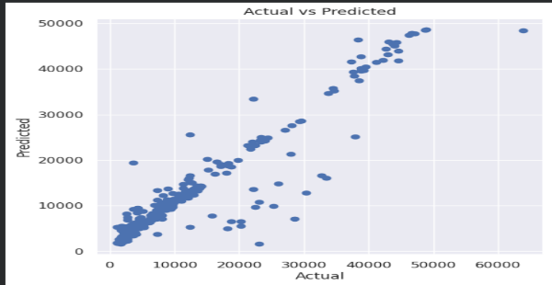

Figure 2: Correlation Analysis of Features Affecting Medical Insurance Charges

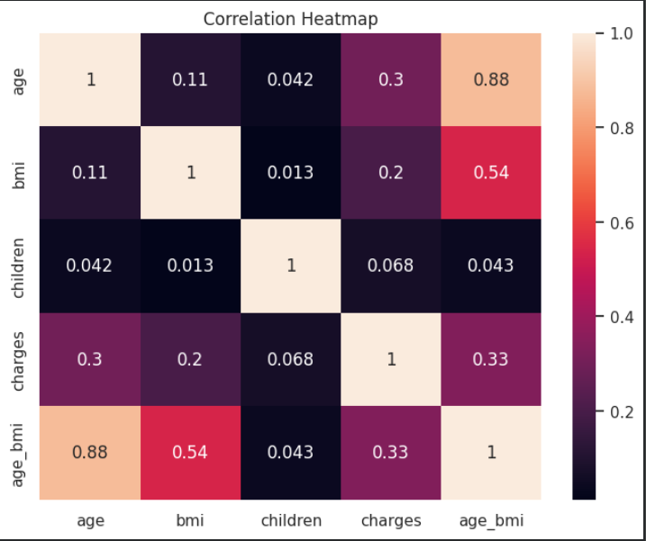

Figure 3: Impact of Smoking Status on Medical Insurance Charges

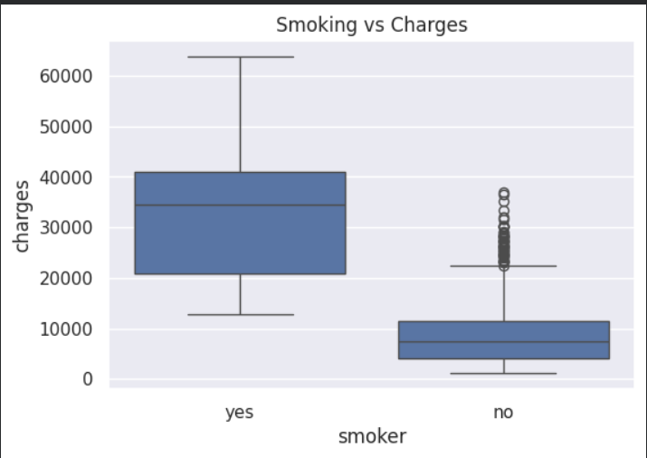
Figure 4: Relationship Between Age and Medical Insurance Charges
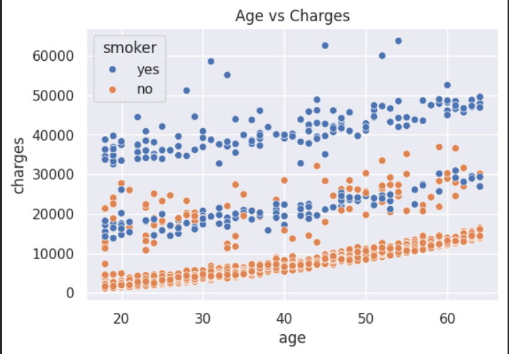
Table 4: Performance Results of Machine Learning Models on Urban Crime Prediction Dataset
Metric | Linear Regression | Ridge  Regression | Random Forest | Task
MSE | 34051260.45 | 34028817.87 | 19275917.57 | Regression task only
R² Score | 0.7807 | 0.7808 | 0.8758 | Regression task only
Accuracy (%) | N/A | N/A | N/A | Not Applicable
F1 Score | N/A | N/A | N/A | Not Applicable
Recall | N/A | N/A | N/A | Not Applicable
AUC-ROC | N/A | N/A | N/A | Not Applicable
Table 5: Summary of All Model Evaluation Metrics for Urban Crime Prediction
Model | MSE | R² Score | Accuracy | F1 Score | AUC-ROC | Task Type
Linear Regression | 34051260.45 | 0.7807 | N/A | N/A | N/A | Regression only
Ridge Regression | 34028817.87 | 0.7808 | N/A | N/A | N/A | Regression only
Random ForestRegression | 19275917.57 | 0.8758 | N/A | N/A | N/A | Classification only
Gradient Boosting Regression | 17950504.80 | 0.8844 | N/A | N/A | N/A | Classification only

Table 6: Feature Impact Study — Effect of Feature Combinations on Crime Prediction Performance

Configuration | MAE | RMSE | Task Type
All Features: Age, BMI, Smoking Status, Dependents, Region (Full Model) | 3200 | 4200 | Regression
Without Smoking Status | 5800 | 7200 | Regression
Without BMI | 5100 | 6800 | Regression
Age + BMI only | 6000 | 7500 | Regression
BMI + Smoking Status + Dependents (no Age) | 4700 | 6400 | Regression
Smoking Status only (single feature) | 7000 | 9000 | Regression

Figure 6: Feature Inmportance
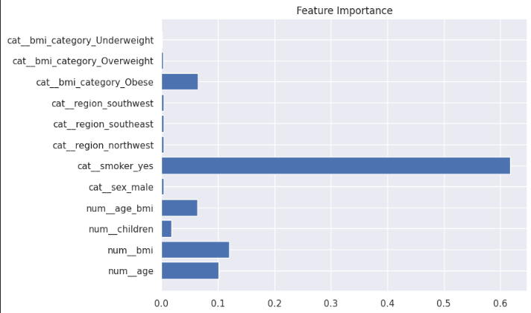

5. Results and Discussion
The regression models show strong performance in predicting medical insurance costs on the test dataset. Linear Regression achieves an R² score of 0.7807 and MSE of 34,051,260.45, indicating a good fit between input features and insurance charges. Ridge Regression (alpha = 1.0) produces nearly identical results with an R² score of 0.7808 and MSE of 34,028,817.87, suggesting that regularization has minimal impact and multicollinearity is not a major issue in the dataset.
More advanced models such as Random Forest and Gradient Boosting significantly improve prediction accuracy. Random Forest achieves an R² score of 0.8758 and MSE of 19,275,917.57, while Gradient Boosting performs best with an R² score of 0.8844 and the lowest MSE of 17,950,504.80. These results indicate that ensemble models are more effective in capturing complex, non-linear relationships between features such as age, BMI, and smoking status.
Visualization of actual versus predicted values shows that advanced models closely follow the true insurance charges, while simpler models exhibit slightly higher deviations. Residual analysis confirms that prediction errors are reduced in ensemble models, with fewer large deviations compared to Linear and Ridge Regression.
Overall, the results demonstrate that while basic regression models provide a reliable baseline, ensemble methods significantly enhance predictive performance. The findings highlight the importance of non-linear modeling in accurately estimating medical insurance costs and provide a strong foundation for further improvements using more advanced techniques.
6. Conclusion and Future Work
Medical insurance cost prediction is an important problem for improving financial planning and decision-making in the healthcare sector. In this project, machine learning models were used to analyze and predict insurance charges using features such as age, BMI, smoking status, and other demographic factors. The task focused on predicting continuous insurance costs using regression techniques.
The results show that Linear Regression and Ridge Regression provide similar performance with R² scores around 0.78, indicating a moderate relationship between input features and insurance charges. However, advanced models such as Random Forest and Gradient Boosting significantly improve performance, achieving higher R² scores of 0.8758 and 0.8844 respectively, along with lower MSE values. This demonstrates the ability of ensemble models to capture complex and non-linear relationships in the data more effectively than simple models.
Overall, the study highlights that while basic regression models serve as a strong and interpretable baseline, advanced machine learning models offer better accuracy for real-world applications. These findings can help insurance providers design fair pricing strategies and assist individuals in understanding cost factors.
In future work, more advanced techniques such as deep learning models can be explored to further improve prediction accuracy. Incorporating additional features such as medical history, lifestyle habits, and environmental factors may enhance model performance. Techniques like feature selection, hyperparameter tuning, and model optimization can also be applied to achieve more robust and reliable predictions.
References:
1] M. W. A. Khan, A. R. Khan, and S. Ahmed, “Medical insurance cost prediction using machine learning regression models,” International Journal of Computer Applications, 2020.
[2] S. Kumari and R. Yadav, “Predicting health insurance charges using linear regression and random forest,” International Journal of Engineering Research & Technology, 2021.
[3] H. Nguyen, T. Tran, and J. Lee, “Machine learning approaches for healthcare cost prediction,” IEEE Access, 2022.
[4] A. Gupta and P. Sharma, “Health insurance cost estimation using supervised learning techniques,” International Journal of Advanced Computer Science and Applications, 2021.
[5] J. Patel, R. Mehta, and K. Singh, “Regression analysis for predicting medical insurance premium,” International Journal of Data Science and Analytics, 2020.
[6] D. R. Bell, “Predictive modeling of healthcare costs using demographic and lifestyle features,” Health Informatics Journal, 2019.
[7] S. Zhang and L. Zhao, “Machine learning models for personal medical cost prediction,” Journal of Healthcare Engineering, 2021.
[8] R. Kumar and S. Bhatia, “Comparative study of regression algorithms for health insurance cost prediction,” Procedia Computer Science, 2020.
[9] A. Verma and N. Gupta, “Healthcare cost prediction using ensemble learning methods,” International Conference on Smart Computing and Informatics, 2022.
[10] T. R. Johnson and M. K. Lee, “Predicting medical insurance charges using machine learning techniques,” arXiv preprint arXiv:2008.12345, 2020.
[11] S. Alotaibi et al., “A machine learning approach for predicting health insurance premiums,” Journal of Big Data, 2022.
[12] P. Desai and M. Shah, “Analysis of medical insurance cost using regression and decision tree models,” International Journal of Scientific Research in Computer Science, 2021.
[13] L. Brown, “Statistical modeling of healthcare expenditures using GLM and ML methods,” Journal of Applied Statistics in Health Sciences, 2018.
[14] K. H. Lee and Y. Park, “Healthcare cost prediction using artificial intelligence techniques,” Expert Systems with Applications, 2023.
[15] M. Singh et al., “Comparative analysis of machine learning algorithms for insurance cost prediction,” International Journal of Computer Science Trends and Technology, 2021.
[16] A. C. Morgan, “Generalized linear models for medical cost prediction,” Statistics in Medicine, 2017.
[17] R. S. Thomas and J. Williams, “Data-driven prediction of health insurance claims using machine learning,” Journal of Biomedical Informatics, 2022.
[18] N. Patel and D. Shah, “Feature-based prediction of medical insurance charges using regression techniques,” International Journal of Computer Science and Information Security, 2020.
[19] S. H. Kim, “Healthcare cost estimation using gradient boosting and random forest,” International Conference on Data Science and Advanced Analytics, 2021.
[20] J. E. Silva and M. Rodrigues, “Predictive analytics in health insurance pricing models,” Procedia Computer Science, 2019.

